Login Page
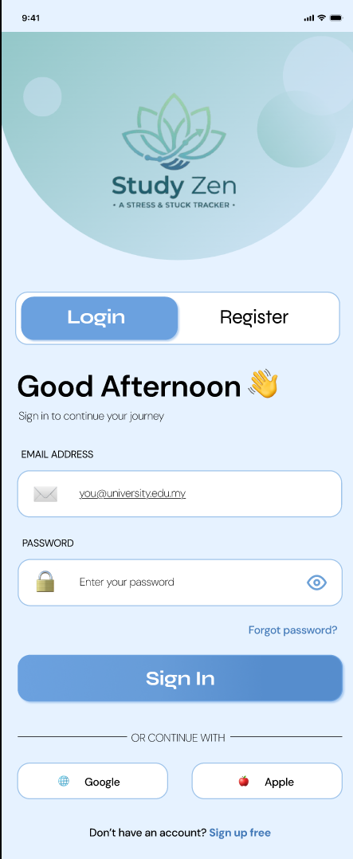Figure 1: Login Interface
The login page allows students to securely access the system using their registered email and password. This ensures that personal study data and stress records are protected and accessible only to authorised users.

Key elements include:
• Email input field
• Password input field
• Login button
• Link to register a new account

This page serves as the main entry point to the system
Register Page
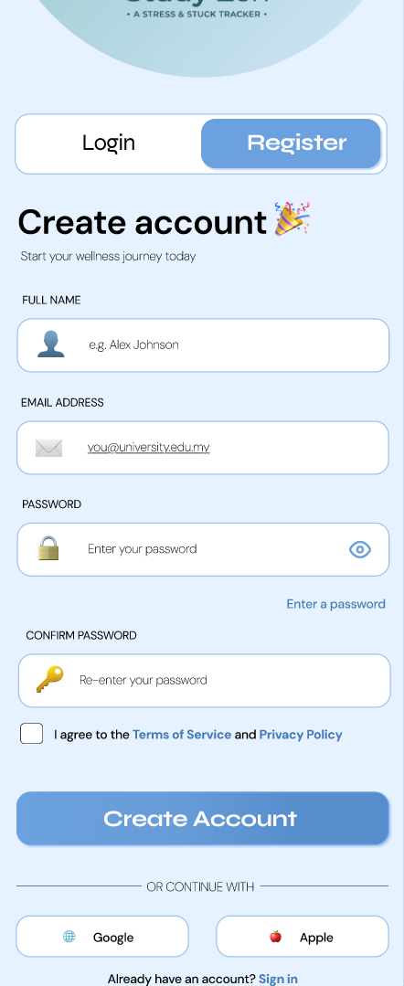
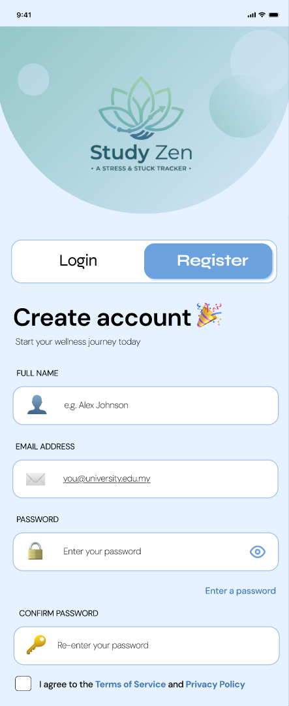

Figure 4.2: Register Interface
The registration page allows new users to create an account in the system. Students are required to provide their personal information such as name, email address, and password in order to successfully register.

Key elements include:
• Name input field
• Email input field
• Password creation field
• Register button

After registration, users can log in and begin using the system features.

Home Page
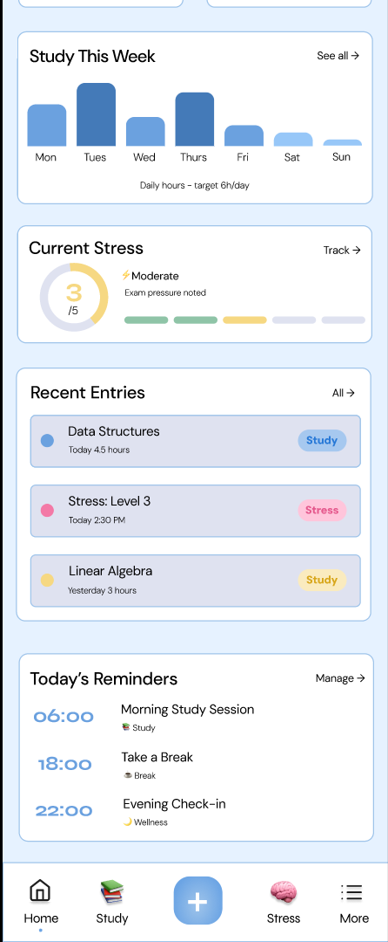
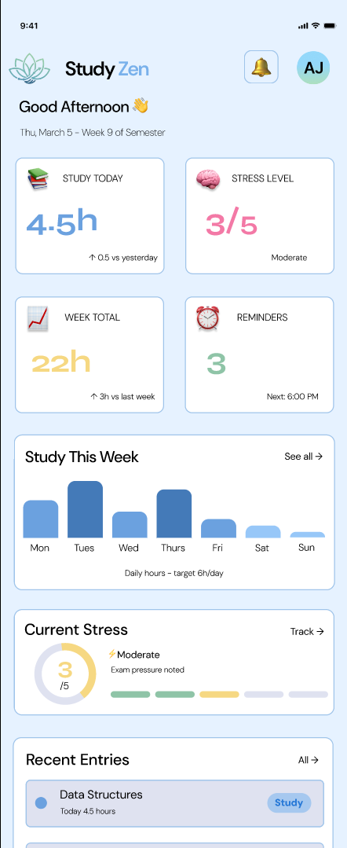

Figure 4.3: Home Interface
The home page acts as the main dashboard of the system. It provides users with quick access to important features and displays an overview of their study and stress tracking activities.

Key features include:
• Navigation menu to access system functions
• Overview of study tracker
• Overview of stress tracker
• Quick access buttons to key features

The home page helps students quickly navigate the system and monitor their study progress.

Study Tracker Page
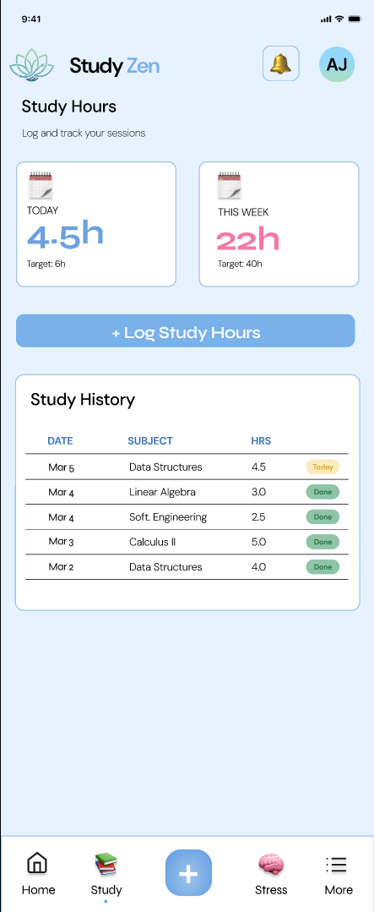Figure 4.4: Study Tracker Interface
The study tracker page allows students to monitor their study activities and access tools that help them record their study sessions. This feature encourages students to maintain consistent study habits.

Key elements include:
• Access to log study hours
• Display of recorded study information
• Navigation to study logging features

This page allows students to manage and track their study activities effectively.

Log Study Hours Page
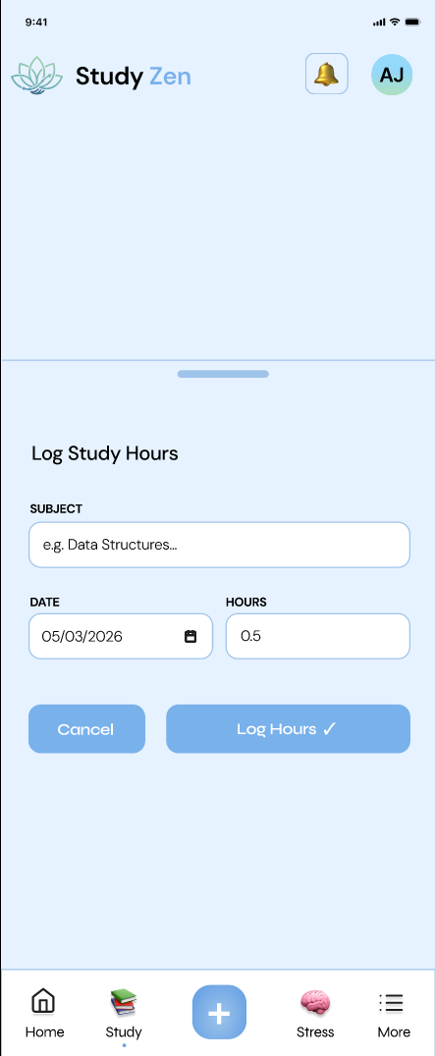Figure 4.5: Log Study Hours Interface
The log study hours page allows students to record the number of hours they spend studying. Recording study hours helps students develop better time management and understand their study habits.

Key elements include:
• Study hours input field
• Date selection option
• Save entry button

This feature enables students to keep track of their daily study time.

Log Entry Page
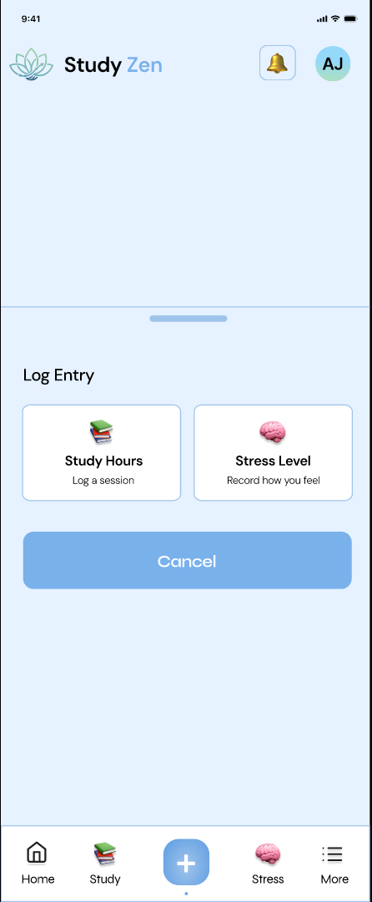Figure 4.6: Study Log Entry Interface
The log entry page displays previously recorded study sessions. Students can review their past study records and analyse their study patterns over time.

Key elements include:
• List of previous study entries
• Date and study hour records
• Option to review study history

This page helps students reflect on their productivity and maintain consistent study habits.

Stress Tracker Page
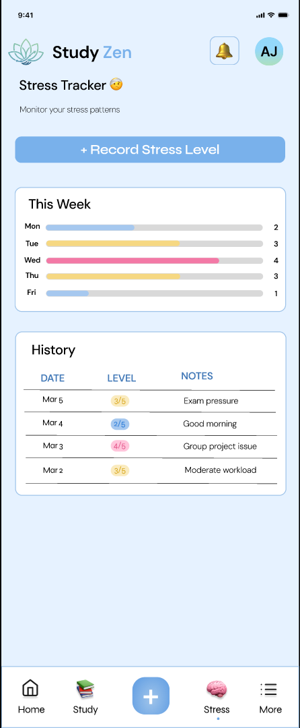Figure 4.7: Stress Tracker Interface
The stress tracker page allows students to monitor their stress levels regularly. Tracking stress levels helps students identify patterns and manage their emotional well-being.

Key elements include:
• Access to log stress levels
• Display of recorded stress data
• Navigation to stress logging page

This feature encourages students to stay aware of their mental health status.

Log Stress Level Page
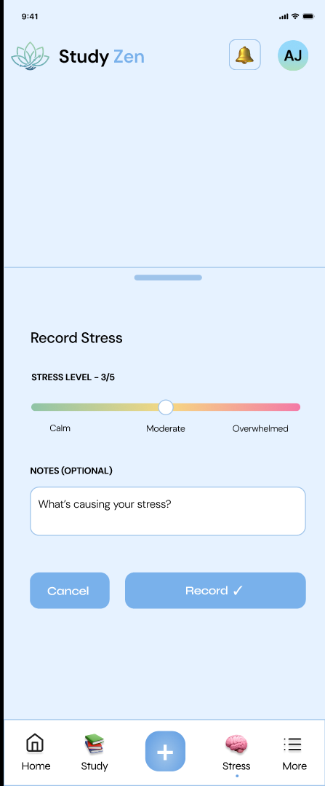Figure 4.8: Log Stress Level Interface
The log stress level page allows students to record their daily stress level using a simple rating system. This makes it easy for students to reflect on how they feel during

their academic activities.
Key elements include:
• Stress level selection scale
• Save stress entry button
• Option to view previous stress records

Recording stress levels helps students recognise emotional patterns and take necessary actions to reduce stress.

More Page
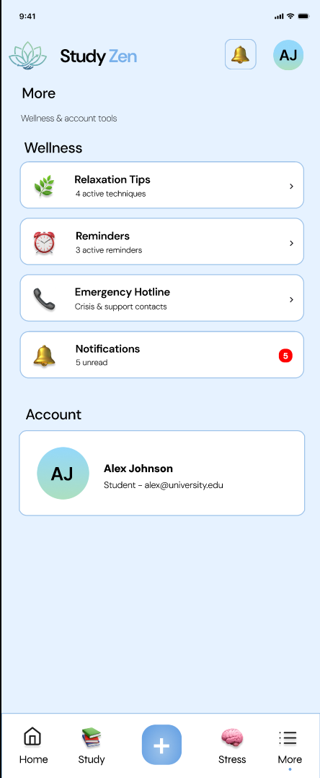Figure 4.9: More Interface
The more page provides additional system features that support student well-being and productivity. It acts as a secondary navigation page for accessing extra functions of the system.

Key elements include:
• Access to relaxation tips
• Reminder management
• Emergency support resources

This page provides students with additional tools that enhance their study and mental wellness experience.

Relaxation Tips Page
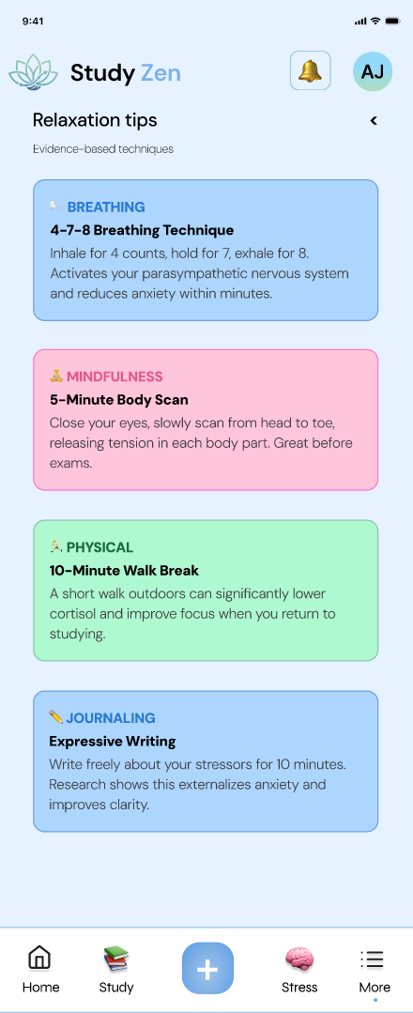Figure 4.10: Relaxation Tips Interface
The relaxation tips page provides helpful suggestions that encourage students to reduce stress and maintain a healthy study routine.

Examples of suggestions include:
• Breathing exercises
• Short break activities
• Relaxation and mindfulness tips

These tips help students manage academic pressure and avoid burnout.

Reminder Page
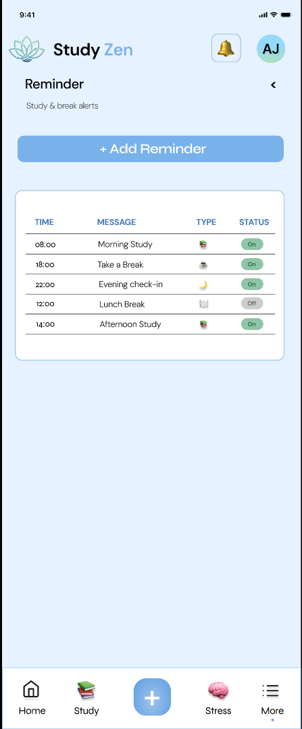Figure 4.11: Reminder Interface
The reminder page allows students to manage reminders related to their study schedule. These reminders help students stay organised and maintain a balanced study routine.

Key elements include:
• List of existing reminders
• Option to create a new reminder
• Reminder notification settings

This feature encourages effective time management.

Add Reminder Page
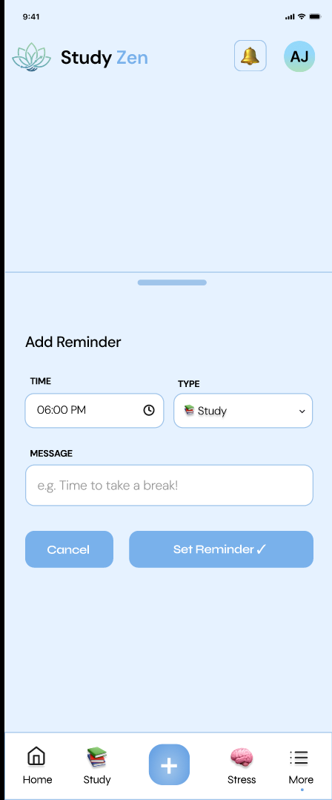Figure 4.12: Add Reminder Interface
The add reminder page allows students to create new reminders for study sessions, breaks, or other important tasks.

Key elements include:
• Reminder title input field
• Date and time selection
• Save reminder button

This feature helps students organise their study schedule more effectively.

Emergency Support Page
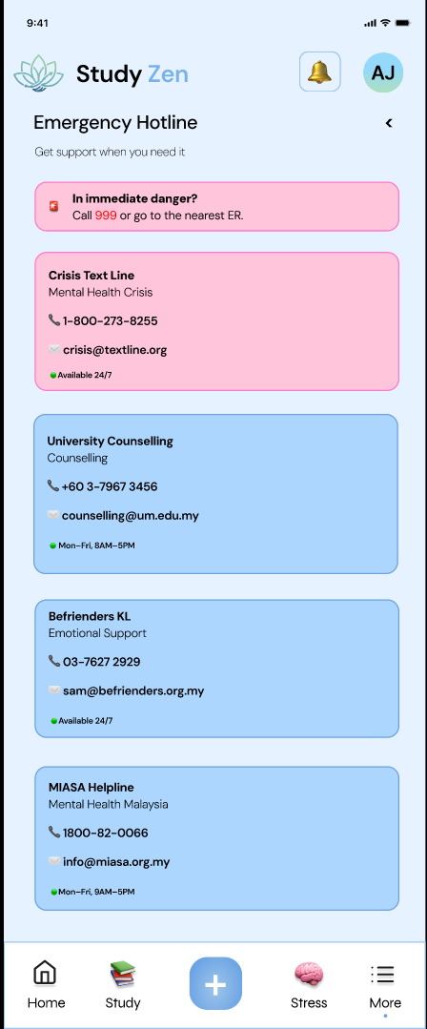Figure 4.13: Emergency Support Interface
The emergency support page provides students with quick access to mental health resources and professional support services. This feature ensures that students can seek help when experiencing high levels of stress or emotional distress.

Key elements include:
• Mental health hotline contact numbers
• University counselling services
• Crisis support information

This feature supports the goal of SDG 3: Good Health and Well-Being by promoting mental health awareness and accessible support resources.

Notifications Page
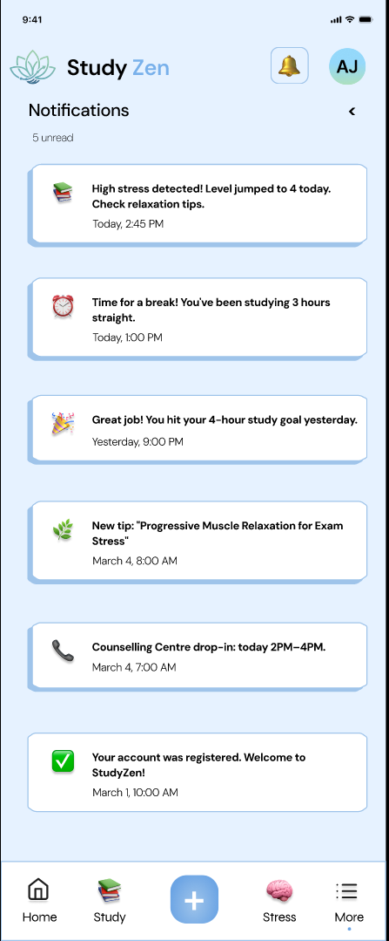Figure 4.14: Notification Interface
The notification page displays reminders and alerts related to study sessions, stress tracking, and other important activities within the system.

Key elements include:
• Reminder notifications
• System alerts
• Study schedule updates

Notifications ensure that students remain informed and organised while using the system.

